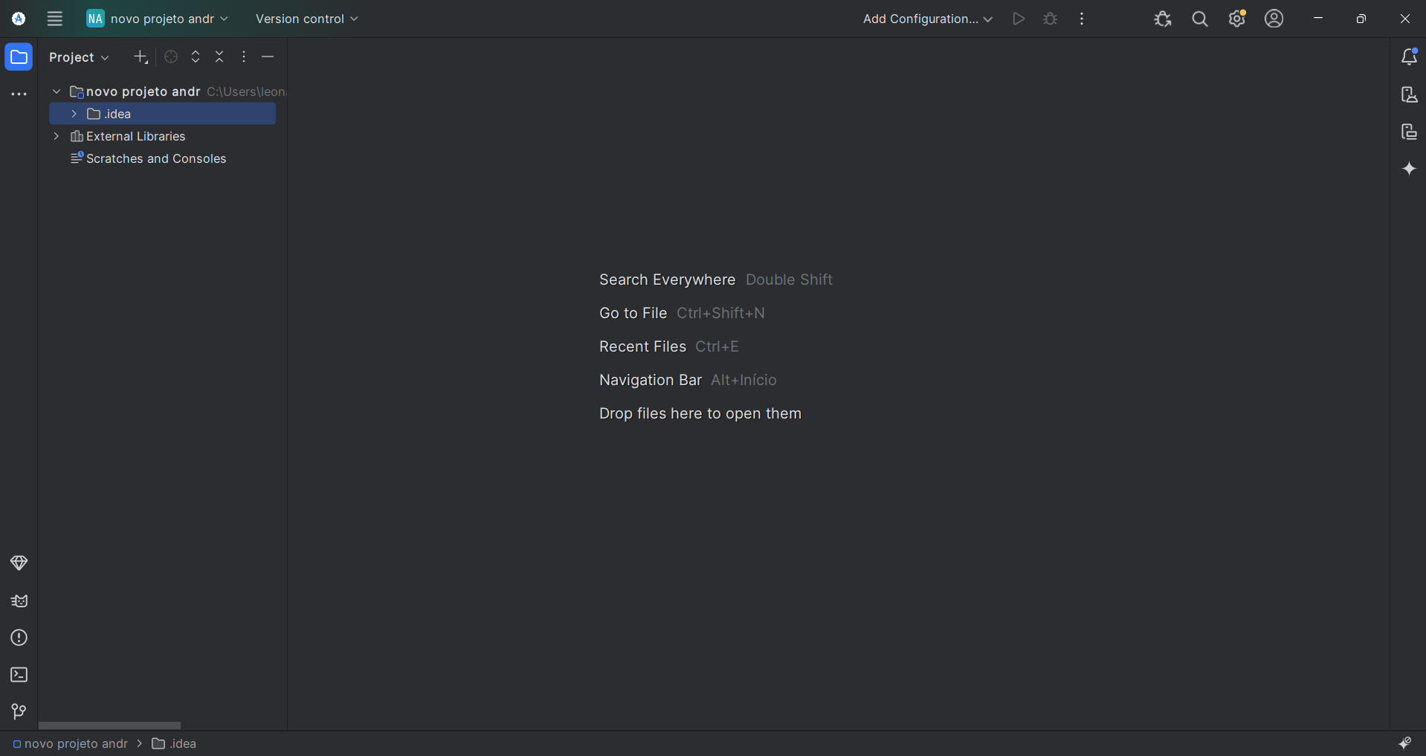

android-studio-2025.1.2.11-windows instalado